ECA5604-5G/6G COMMUNICATION SYSTEMS
NAME: V Sadhana
REG NO: 192412242
Exp 7: Analog Beamforming Analysis Using MATLAB
Objective-1
Generate beamforming gain values for different antenna array sizes using MATLAB. Compare how increasing the number of antenna elements improves the beamforming gain and enhances signal strength
Code:
clc;
clear;
close all;
ntennas = [2 4 8 16 32]; % Number of Antenna Elements
gain = 10*log10(antennas); % Beamforming Gain (dB)
figure
bar(antennas, gain)
grid on
xlabel('Number of Antenna Elements')
ylabel('Beamforming Gain (dB)')
title('Beamforming Gain for Different Antenna Array Sizes')
Output:
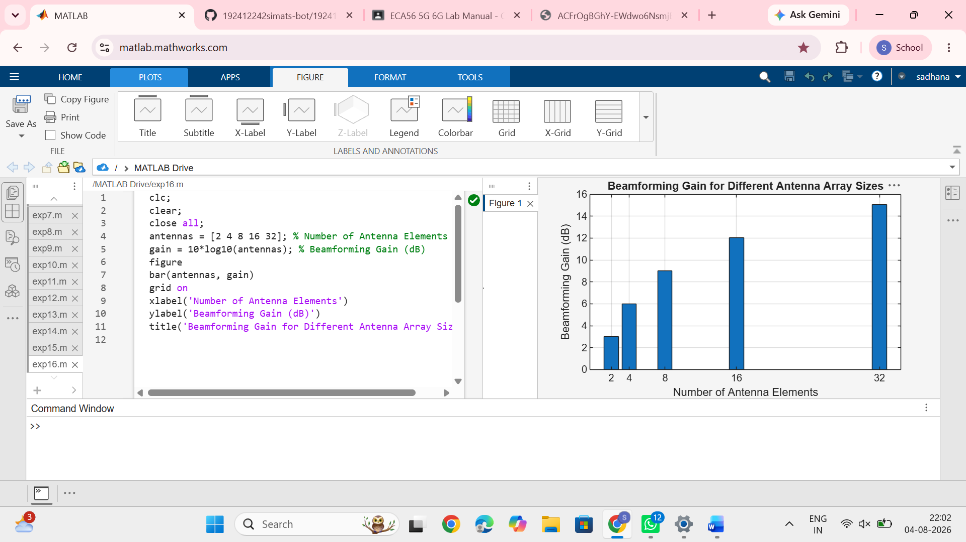
Objective-2
Analyze the beam width corresponding to different antenna array sizes using MATLAB. Observe how increasing the number of antenna elements results in a narrower beam, thereby improving spatial resolution.
Code:
clc;
clear;
close all;
antennas = [2 4 8 16 32]; % Number of Antenna Elements
beamwidth = [90 45 22.5 11.25 5.625];
% Beam Width (degrees)
figure
plot(antennas, beamwidth,'o-','LineWidth',2)
grid on
xlabel('Number of Antenna Elements')
ylabel('Beam Width (Degrees)')
title('Beam Width for Different Antenna Array Sizes')
Output:
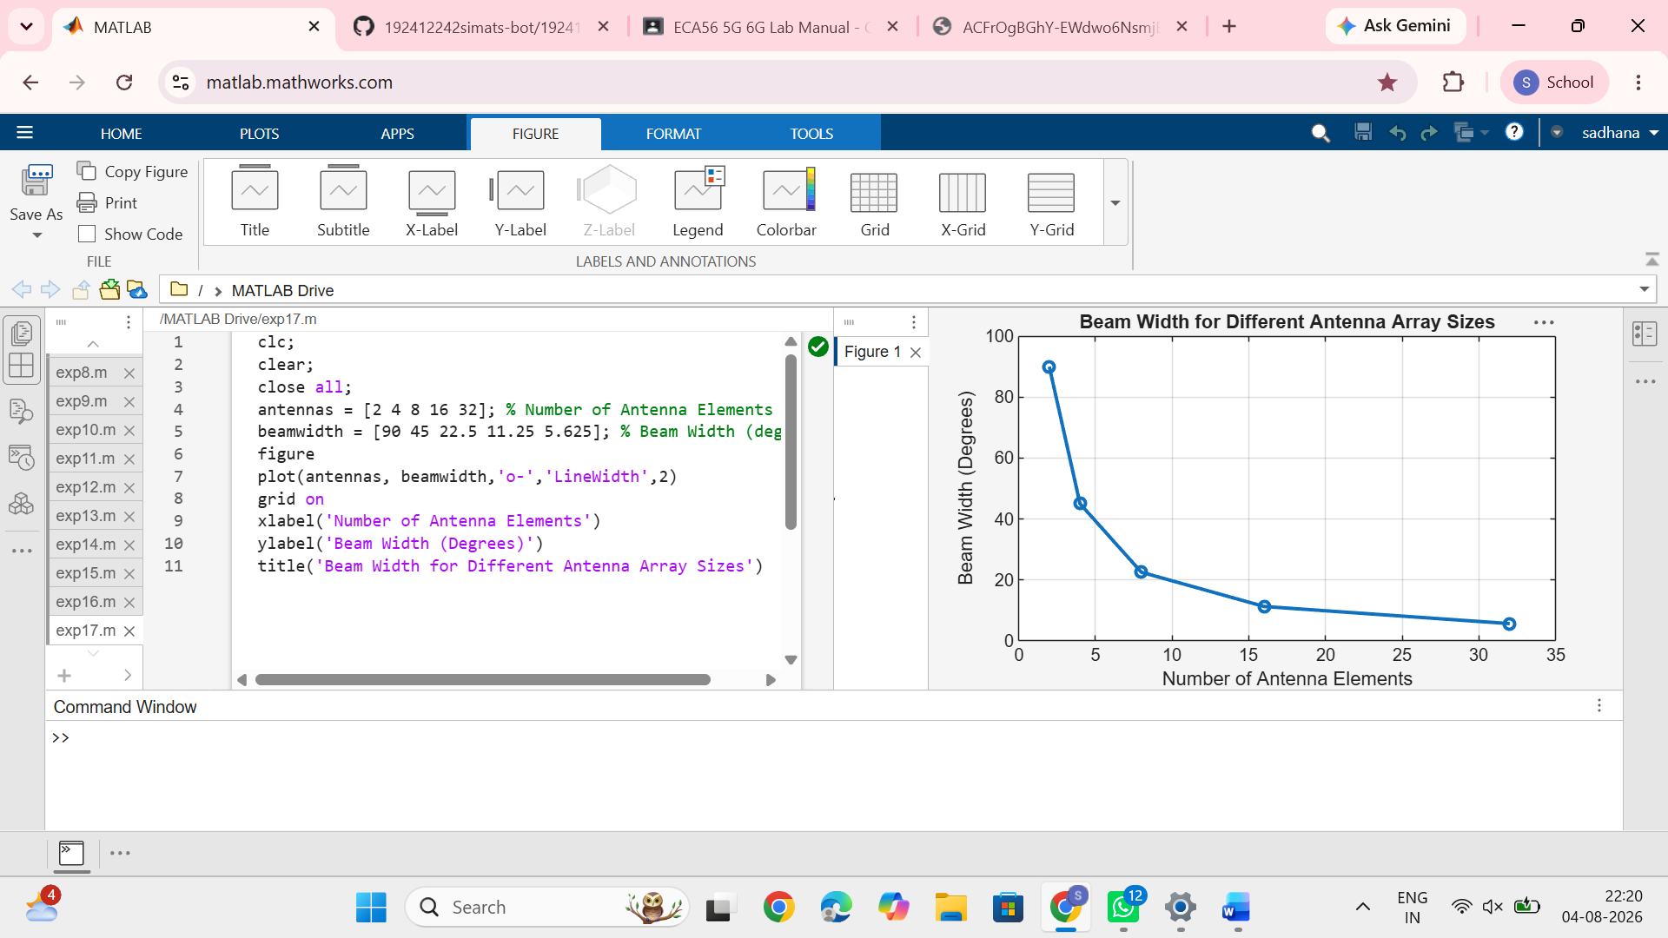
Objective-3
Simulate beam steering by varying the steering angle of the antenna array using MATLAB. Observe the change in the main lobe direction and understand how analog beamforming directs energy toward the intended user.
Code:
clc;
clear;
close all;
theta = [-60 -30 0 30 60]; % Main Lobe Direction (degrees)
gain = [1 1 1 1 1]; % Constant normalized gain
figure polarplot (deg2rad(theta), gain, 'o', 'LineWidth', 2)
title('Main Lobe Direction in Analog Beamforming')
Output:
